2013
David McPhillips

3rd Floor, Theatre Court, 15 Lower Mallow Street, Limerick
Ph. (061) 317 688
www.csmt.ie

[CASP CSMT ANNUAL REPORT 2013]
CASP Community Substance Misuse Team is voluntary organisation with charitable status
CHY 15069

Funded through the H.S.E. by the Mid-West Regional Drugs Task Force.

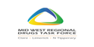
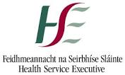

Name of Project Promoter:

Clondalkin Addiction Support Programme
Address: Ballyowen Meadows, Fonthill Road, Dublin 22

Community Substance Misuse Team MW40
3rd Floor, Theatre Court, 15 Lower Mallow Street, Limerick

Contact Name:
Project Manager, Maria Finn Telephone Number: 01 616 6750; 061 317 688
Fax Number: 01 616 6755
Team Leader, David McPhillips, 0864141897
E-mail: dmcphillips@csmt.ie

President/Chairperson
Name: Eddie D’Arcy
Address: Catholic Youth Care, Arran Quay, Dublin 1

Secretary or Treasurer
Name: Frank Schnittger
Address: C/o CASP, Ballyowen Meadows, Fonthill Road, Clondalkin, Dublin 22

Chairperson’s Foreword

CASP CSMT is now in its second year of operation. As a new service development, in a new geographical area for us, it has been both challenging and rewarding experience for us as an organisation. The service has been well received in the region by existing services, and the level and range of interventions developed have been both exciting and challenging for all concerned.

CASP’s ethos has transferred to the emerging CSMT service, where the focus of resource allocation for the benefit of those whom the service is provided for, is the primary concern. In this regard CASP CSMT respects and values existing local services, and are happy to work with and support and /or assist in the development of local solutions, to the emerging challenges that young people and families are facing, in the area of substance misuse. We would like to extend our gratitude to all agencies and service providers and offer a commitment to the continued joint efforts to improve the circumstances and outcomes of/for the individuals and families we are privileged to work with.
Within this report you will see the types of approaches we use, numbers seen, and programmes offered. We recognise the importance of this for our funders and for the effective delivery of evidenced based programmes and hope it provides an insight to the range of actions taken by the team.

However, as an agency working from a community development perspective, the outcomes as perceived and experienced by those who use our services, is our measure of success or failure. Has quality of life improved for individuals and their families? Have alternatives to substance use been fully explored and can they be availed of by young people and their families? Has there been discussion and debate as to the issues impacting on people’s lives and the lives of those who live in the community? Are there actions and/or additional factors that could be or are relevant to the lives of those we meet and what can we as a team do that will make a difference today!

We are delighted to have the opportunity to serve the people of the mid-west and hope to continue doing so in the coming years.

What CASP CSMT does?

CASPCSMT provides a free service to under 18’s and their families who are affected by substance misuse in the Mid-West region. We work from the principles of empathy, positive regard, and solution focus to enable effective outcomes to be delivered for youths and family members in the Mid-West.

Aims of the Organisation:
The aim of CASP CSMT is the provision of supports and related educational and practical interventions to support and facilitate a range of on-going services, targeted at supporting the parents, family members, partners and young people living with impact of substance misuse

Background

Research shows that where young people do develop a problem with drugs and alcohol, the involvement and support of parents and families can make a big difference to the person’s health and their ability to deal with their drug habit. CSMT believes in working with young people and their caregivers to develop a long term sustainable supported environment.

How?
Using evidence based practices (Adolescent Community Reinforcement Approach, CRAFT, 5 Step Method and MI) CASP CSMT aspires to:
- Create a rewarding, structured non drug using life for young people
- Engage young people in alternative attractive activities
- Build quality relationships within family and wider community
- Focus on strengths and positives
- Bring young people to a place of choice and responsibility in their decision making regarding substance misuse
- Develop effective coping responses for concerned persons
- Improve problem solving and communication
- Reduce stress for those impacted by substance misuse.

CASP CSMT Services:

CASP CSMT Organisational Structure:

CASP Management Committee
Project Manager-
Maria Finn
Team Leader-
David McPhillips

Project Worker – Teresa Walsh
Clare
Project Worker-
Mags Dillon
Co. Limerick
MWRDTF / HSE
CSMT Advisory Board
Administrative Support- Jenni Raftery

Project Worker-
Joe Slattery
North Tipperary

Social Worker-
Kirsteen Laing
Limerick City

CSMT in the Mid-West

A focus for the CSMT is the geographic areas that may not at present have easy access to services with referrals being accepted to date from a host of agencies and individuals themselves. Whilst the service is based on a multi-systemic approach, it is crucial that families and young people feel that their needs are met in a manner that does not further marginalise or socially exclude them from society.
CSMT created a number of drop in centres localised in the region to provide support and accessibility to CASP CSMT in the community

Outreach Centres

Limerick City

Clare

North Tipperary

Co. Limerick

Number of Referrals:

- Number of Referrals 2012 110 comprising of youths and concerns persons.

- Number of Referrals 2013 213 comprising of youths and concerns persons.

Referral Breakdown:

Number of new referrals during 2013 – Total 211
Co Limerick : 54
Limerick City: 53
North Tipperary: 60
Clare: 44

One to One’s for 2013
 | One to One's
 | Youths | Concerned Person | Youth and Parents
Limerick City | 213 | 46 | 15
North Tipperary | 167 | 45 | 5
Co. Limerick | 172 | 88 | 33
Clare | 184 | 82 | 8
Mid-West Additional | 110 | 33 | 4

Referral Breakdown

Outcomes for these sessions included:

- CRA- Functional analysis raising awareness of triggers for substance misuse
- Increased pro-social behaviour
- CRAFT model of work with concerned persons
- 5 Step Programme
- Solution focused intervention through a collaborative approach
- Drug reduction
- Alcohol reduction
- Raised awareness of effects of substance misuse, poly drug use
- Lessened the impact of substance misuse on the family unit
- Provided a safe place to discuss issues
- Supporting young people affected by a parental addiction, this includes providing emotional support; education around the nature of addiction and increasing knowledge of various substances. These young people may be particularly vulnerable to substance misuse themselves and this work is seen as preventative
- Improved communication in the family by practising communication skills with the young people.
- Assisted and advocated for young people to achieve goals on their action plan, e.g. looking for courses and activities that the young person may be interested in.
- Education and awareness around substance so that informed choices can be made by the young person.
- Referrals to other agencies where appropriate.

CSMT Family Outcomes:

- Increased awareness and symptoms of substances that are commonly abused by youths.
- Increased awareness of services to support the family and also the substance abuser.
- Support and understanding for the family.
- A safe place for a family member to vent their frustrations and fears of substance misuse.

Challenges when dealing with youths and families:

Staff had to respond to a number of crisis situations over the year which had complex needs and impacted heavily on staff resources.

Nature of Issues presenting in 2013:

Homelessness | Foster placements difficulty | Parental addiction | Mental health issues
Overdose situations | Child protection | Family breakdown | Domestic violence
Sexual assault | Self-harm | Drugs debts | On-going criminal activity

Work Done
- Referrals to Social Work Department
- Detailed Recording and Reviews of child protection issues
- Working with extended family
- Referrals to Aislinn Treatment Centre
- Advice and guidance sought from Psychiatrist from CAMHS
- Referrals to counselling service/family therapy, anger management
- Additional support provided by CSMT
- Referrals and engagement with Novas Respite House
- Education in relation to substances provided to young people and concerned persons
- Involvement in CAF process (Limerick City only)
- Advocating to get young people back to education,
- ACRA and CRAFT, information provided to concerned persons
- Assistance to source accommodation and apply for appropriate benefits
- Referral to parenting course
- Referrals to Pieta House
- Harm reduction work.

Support Groups:

There are a number of support groups and activities running in the area in collaboration with other agencies:
- Roscrea Family Support group – group commenced with 7 participants in Templemore
- Clare Youth Group –collaborative work with HSE, Bushypark, CSMT and Clare Youth Service. Programme commenced with 9 participants as of start date. Weekly review carried out by facilitators and referred to David (CSMT), CSMT have overall responsibility for programme.
- Shannon Youth Group – an ACRA programme with identified at risk youths in collaboration with Shannon Youthreach – 7 participants
- Ennis Youth Group- ACRA programmes delivered for 6 sessions with 10-12 participants
- Roscrea Youth Group – 2 staff members were involved in a weekend away with youths from Roscrea youth club, identified at risk youths. 7 youths over weekend.
- Roscrea Boys Group- 6 youths in a group for one session per week, 6 sessions.
- Strengthening Families Programme – CSMT staff members involved in delivering and assisting the delivery of the strengthening families programmes.
- Templemore Kickboxing Group
- 20/20 Group Thurles – delivery of 6 sessions in substance misuse awareness to 40 participants of the 20/20 group in Thurles
- Southill Area Centre – Drugs awareness group Southill Club2gether 4 participants 6 sessions.

Workshops:

Staff were involved in a number of psycho educational substance misuse pieces throughout the Mid-West:
- Girls Group Roscrea
- Rathkeale Girls Group
- Rathkeale Boys Group
- Hospital Youth Reach Substance misuse session
- Doon Girls School
- Southill Area Centre general community.

Strengthening Families Programme:

CSMT are coordinating and funding the SFP programmes for Hospital FRC, ST. Munchin’s FRC and Southill FRC. SFP is an evidence based skills programme for families.

Action 29 under the prevention pillar of the National Drugs Strategy is to:
• provide supports for families experiencing difficulties due to drug/alcohol use
• improve parenting skills
• targeted measures focusing on the children of problem drug and/or alcohol users aimed at breaking the cycle and safeguarding the next generation (The National Drugs Strategy, 2009-16, p100).

Up to 30 families participated in the SFP programmes throughout the City and County.
Objectives and outcomes from these programmes:
Parent:
- Increased Positive parenting
- Increase in parenting skills
- Increase in parental supervision
- Increase in parental involvement
- Decease in parental substance misuse
Child:
- Increase social skills
- Reduced aggression
- Reduced concentration problems
- Reduced criminal behaviour
- Reduced hyperactivity
Family Unit:
- Increase positive parent /child relationship or family cohesion
- Reduce family conflict
- Increase family organisation and order
- Increase family communication
- Increased overall family strengths and resilience

CRA Support:

All staff at CSMT are now accredited in Adolescent Community Reinforcement Approach, an evidence based model for working with youth substance misusers. Additionally, team leader, David McPhillips is now an ACRA Trainer. CSMT continues to provide CRA support groups for those from the Mid-West looking to obtain accreditation.

Street League:

CSMT in conjunction with the FAI, NOVAS, and Limerick Youth Service started the street league tournament for Limerick, once a week out in the Delta Dome. The aim is to have representation to the International Irish Street League Team from the Mid- West. David McPhillips, Jason O’ Connor and Billy Barrett have been designated to select players to go forward for the trials in May 2014. Ricky Nolan from Novas has helped to coordinate this pro-social activity for at-risk youths each week attracting on average 30-40 participants.

Pathways from CSMT

CSMT utilise a number of the services available in the Mid-West referring to the Respite House on a number of occasions, also working with Aislinn treatment centre, Youth homeless service, Novas, FAI, Saoirse, Ana Liffey, Limerick Youth Service, Clare Youth Service and adult education services.

Inter-agency collaboration:

Roscrea Boys Group | St Augustines | Aislinn | MWRDTF | Saoirse
FAI-Jason Oconnor | Northstar | Bushypark | Barnardos | Young person’s homeless service
Clare and Limerick Youth Services | Traveller support group | HSE Drug and Alcohol Service | Probation | Social work department
Extern | Foroige | Bedford Row | Novas | Respite house
Red Tec | YouthReach | TRYS | Cheim ar Cheim | Focus Ireland
Hospital FRC | Children's Grief Project | Garda Diversion Projects | St Mary's Health Centre | St Munchins FRC
Southill FRC | Northstar | SFP | Ballynanty Health Centre | Le Cheile
YAP | VEC | Northstar | Ana Liffey | Education and Welfare officer

Training:

CSMT hosted the CRA/ ACRA/ CRAFT training in February 2013:

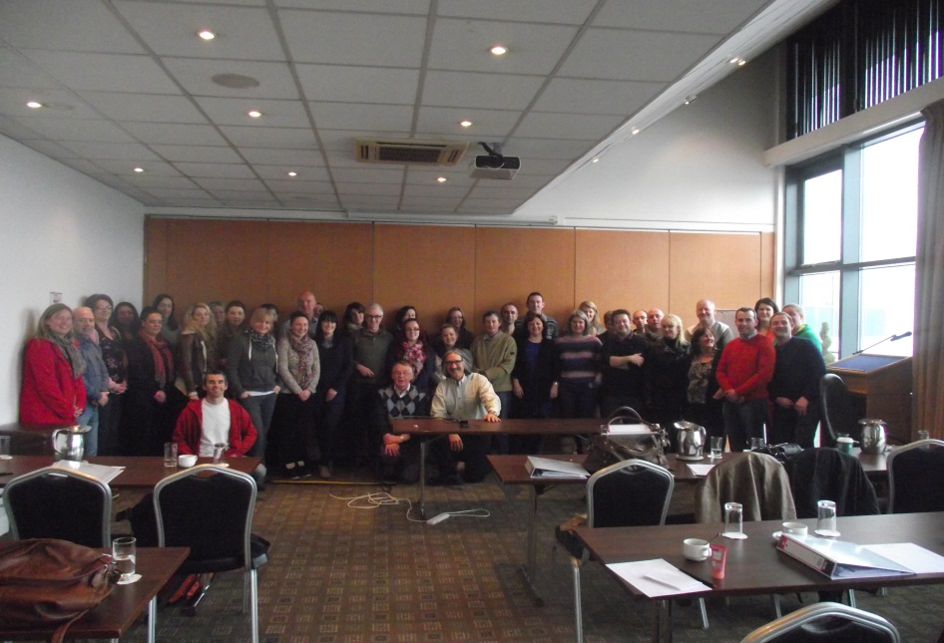

- The ACRA/CRAFT training took place in the last week of February and was a success in terms of delivery, feedback and organisation. An evaluation of the training was carried out, sample of responses as follows: CSMT actively involved in encouraging, motivating and providing support groups for those wishing to avail of CRA/ACRA/CRAFT accreditation throughout the 1st quarter and coming months.

- CASP CSMT certified over 20 people in FETAC Level 5 “Working with Groups” in North Tipperary and Limerick City

- Dr. Billy O’Connor presented a seminar to 20 participants on the impact of addiction on the human brain, looking at how different drugs impact on the brain.

- Gerry Ryan delivered ACRA to the probation service

- Working with Children of problem drinkers: Dr Shane Butler.

- 1st Aid Training- all staff in CSMT trained in 1st aid.

Finance

- Projections for 2014 were submitted to the MWRDTF
- Audit carried out externally on CSMT finances
- 2014 planned spending agreed including budgets for potential pieces of work.

Feedback from service user’s

“Extremely helpful, this is a wonderful service and it has helped me significantly over the period of sessions.”
“I find this service very beneficial, helped us feel our family was normal!! Helped me learn how to deal with difficult situations with my family in a clam and logical manner and also how to detach and relax more.”
“Thank you”
“I am very grateful for the fantastic service that was given to my family at C.S.M.T. from the first day when we walked in off the street looking for help at C.S.M.T. I felt welcome, listened to and a great sense of relief that someone was willing to help”.
“Throughout our time working with C.S.M.T I never once felt judged. We were given good direction in how best to manage home situations. It has been a difficult time for my family and me and I am forever grateful for your help and support”
“This has helped me come off most things and I’m happy about it.”

Sample Referral Feedback:

Sample of feedback from Referral agencies carried out in 2013 through Survey Monkey:
Do you feel the client(s) you referred was responded to in a timely manner?
- 100% answered yes
On a scale of lowest to highest, how do you feel your expectations for referring the client(s) were met?
- 0-4 was the range and the average response was 3.33
Do you feel the quality of life of the client(s) you referred improved (Y/N) and if so how?
- Better communication skills, better family relationship and less strain in the family unit
- Yes, communication and understanding of client's issues improved.
- Yes, both teenagers have an increased awareness of their problematic drug misuse and their drug consumption has reduced allowing them to engage in other supports more effectively
- I feel that the young person I work with was offered significant practical and emotional supports. I feel that the young person will continue to improve with engagement and has developed a great relationship with worker.

